Ammar Ahmed BDS2B2
20L-0961

Lab 12 Tasks
Task 1
a) Negative Edge Triggered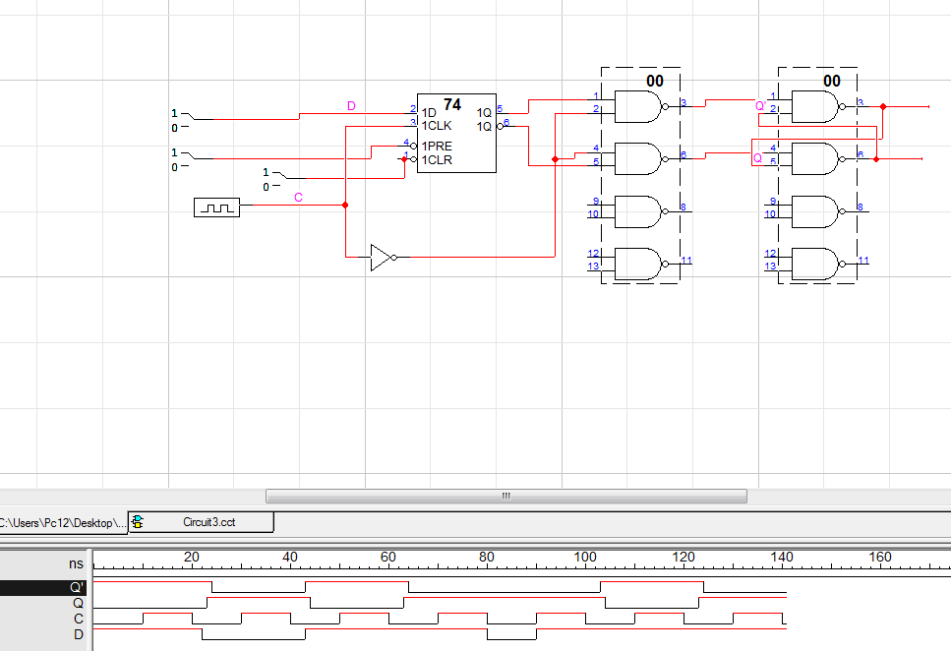b) Negative Edge Triggered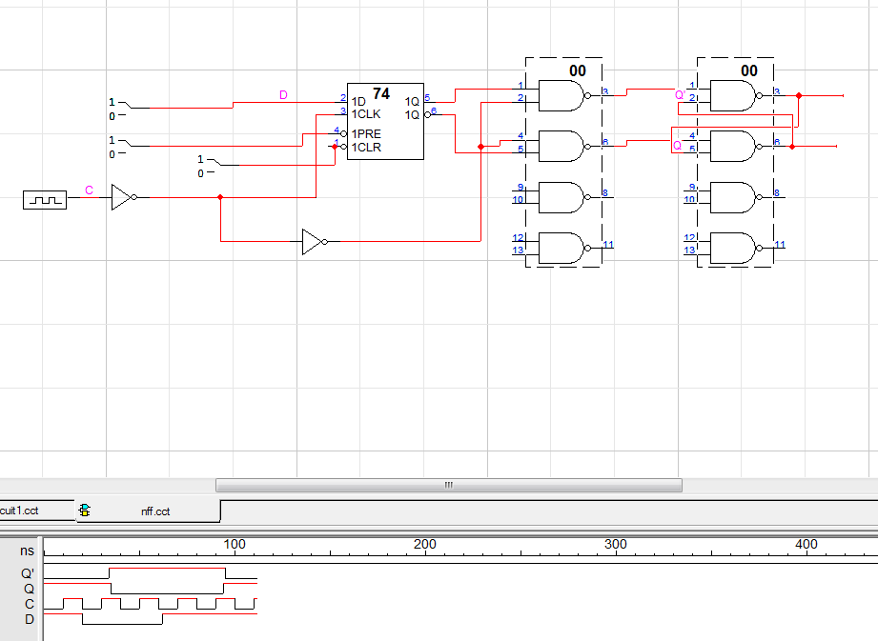

The output of Negative Triggered changes when the clock changes from high to low, i.e. it is negative edge triggered, whereas the output of Positive Triggered changes when the clock changes from low to high, i.e. it is positive edge triggered.

Task 2
a) Negative Edge Triggered
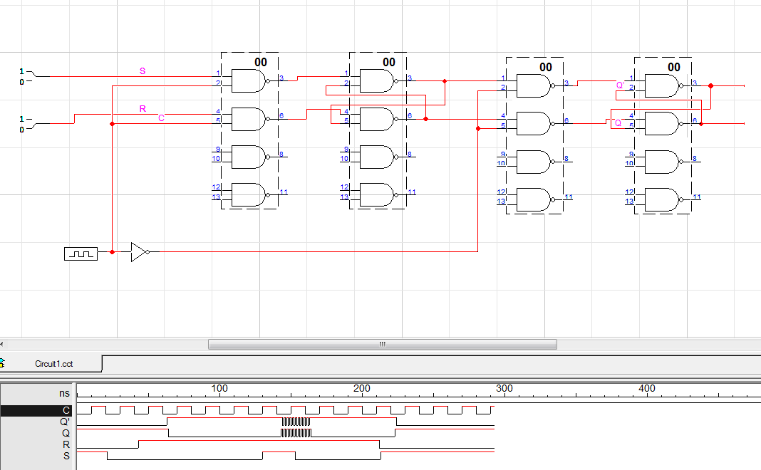
b) Positive Edge Triggered